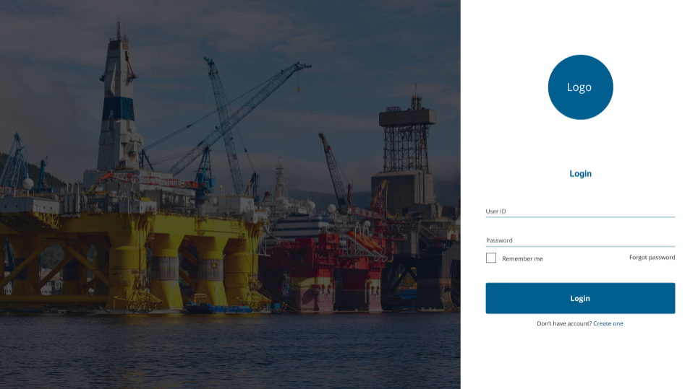

Dashboard

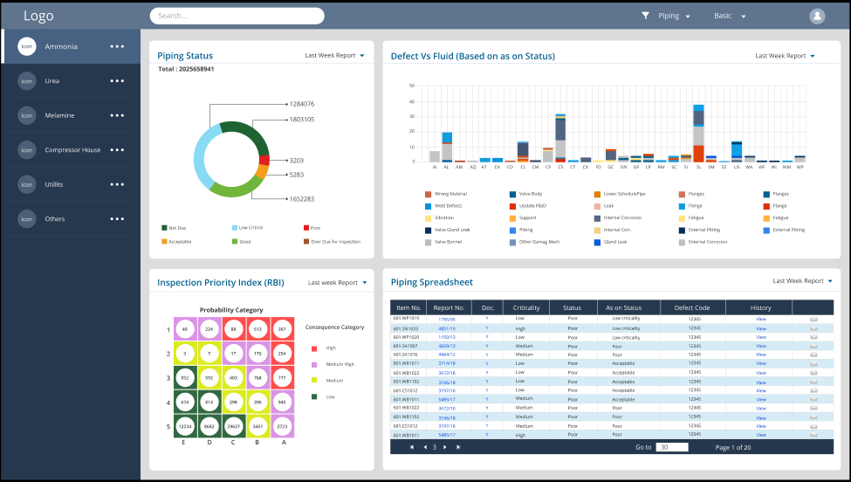

Report

Company Name

Piping Inspection Report

Master Data

Report No (A-xxxx/yy), Work order Number (U- xxxxxxxx) Equipment Number (U- xxxxxxxxxxxx) Date (A- Today), Overall Status (U-POOR/ACCEPTABLE/GOOD)

Retrieve Master Data as per Equipment number

Description, Plant, Line from to , P&ID number, Cluster Number, Material, Fluid, Risk rank, Revised Status

POF

TML

Recom

Distribution

Actions

TML

POF

Pipe Mast

Distribution

Distribution from table including carried by, approved by

Followup

Next Insp date , Follow-up date

Temp repair Y/N, Temp repair followup comment, Sl no (report no/slno), Comment (if available), Present status

Recommendations

Sl no (report no/slno),Recommendation 250, Priority, Responsible, Target date, WO number

+ to add new lines

External condition;

Observations (text 250) + to add new lines

TML table

SCR IC: EC: CUI: LCR IC: EC: CUI:

TML – CUI or EC or IC- Nom Dia-Nom Thk, Min reqThk, MeasuredThk (as Table)

+ to add new lines

Inspection Program – From POF table for this equipment- as table

Damage Mechanism-Priority-Inspection Program-Inspection due date-Confidence-Next Insp Date

